**Introducing**

Contains a Thermal Camera in the front (The phone is used as a placeholder).

***The Thermal Thruster***

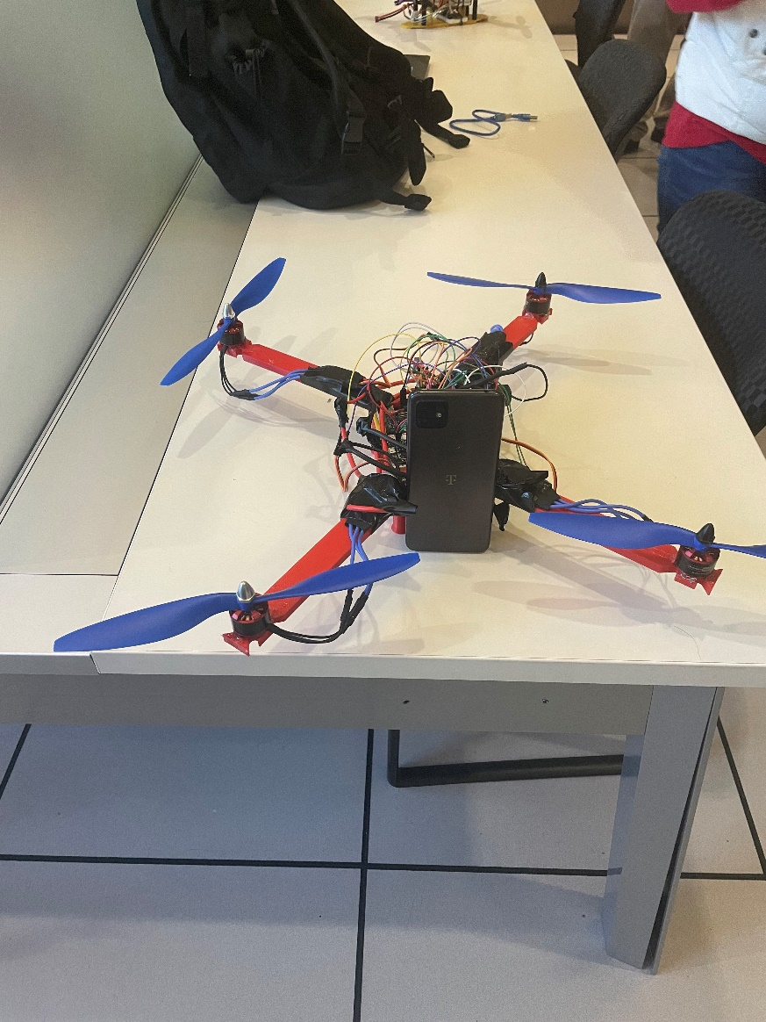

Completely Wireless:

Control the drone from the comfort of your home using a webpage.

Great for Agriculture: Use the camera to see how much water your crops are getting or to check your plants for diseases.

Up to 690 grams of thrust from each motor

For more information, click [here](website/index.html)